Git clone: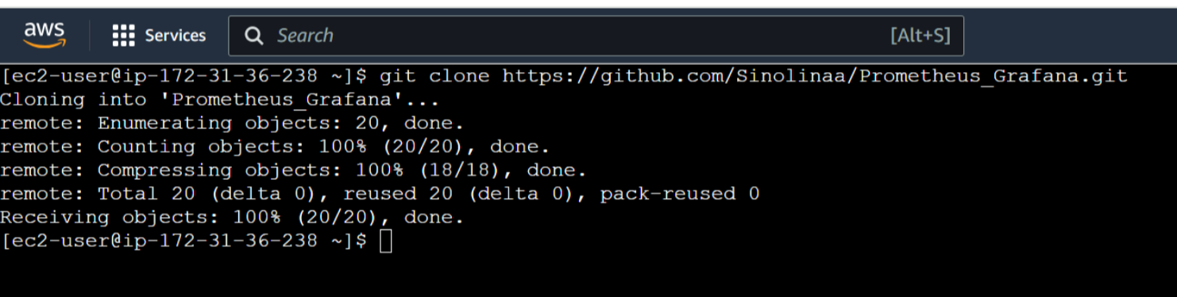

Installing Prometheus: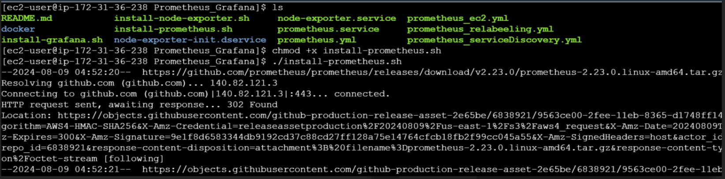

On installation of Prometheus a manifest file called Prometheus will be created in etc/Prometheus path: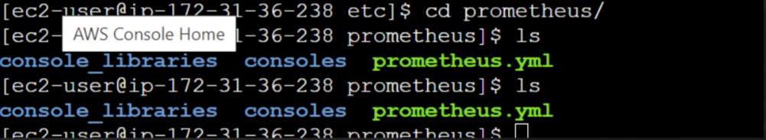

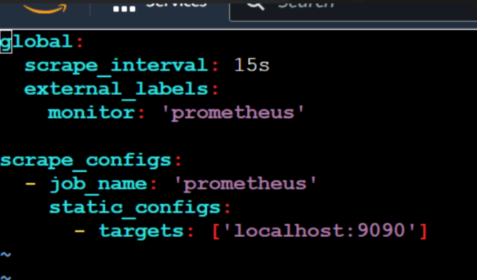

Prometheus security group is 9090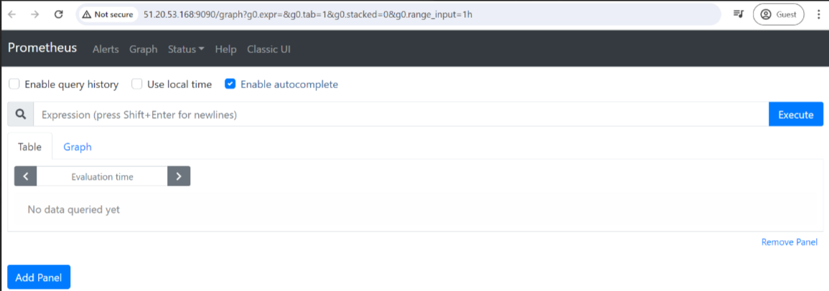

Install node exporter – it will get the metrics and give it to the Prometheus: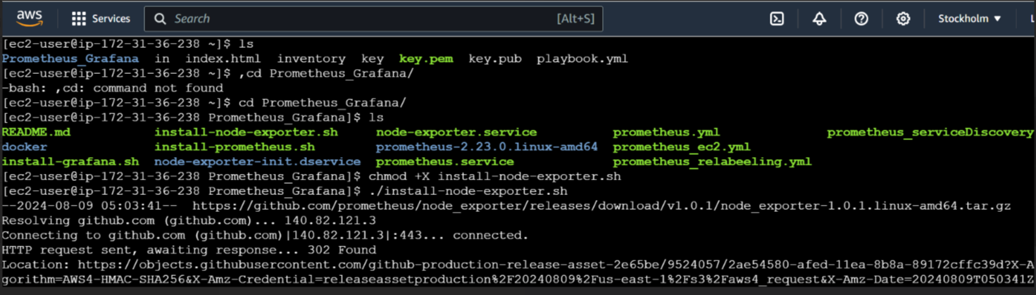

Node exporter runs on port number 9100:

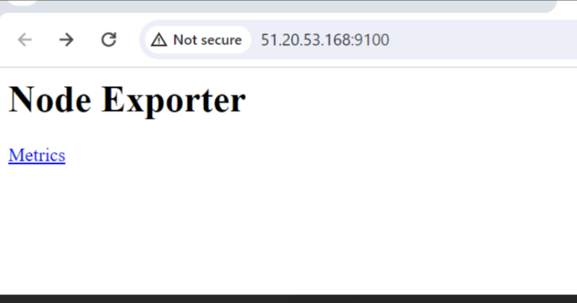

Installing Grafana:

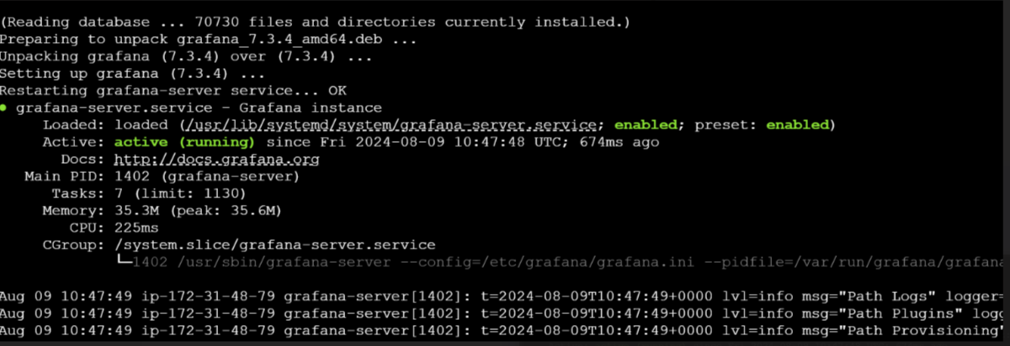

**CREATE TARGET MACHINE INSTALL NODEEXPORTER IN TARGET MACHINE:**

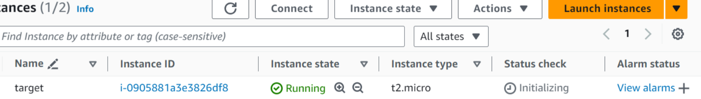

SET TARGET MACGHINE IP IN MONITERING SERVER PROMETHEUS.YAML FILE:

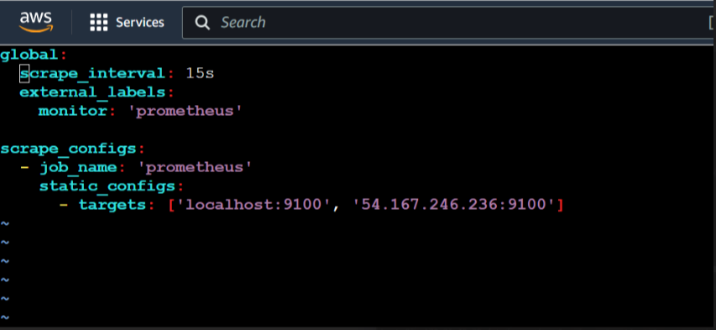

Adding Prometheus datasource to Grafana:

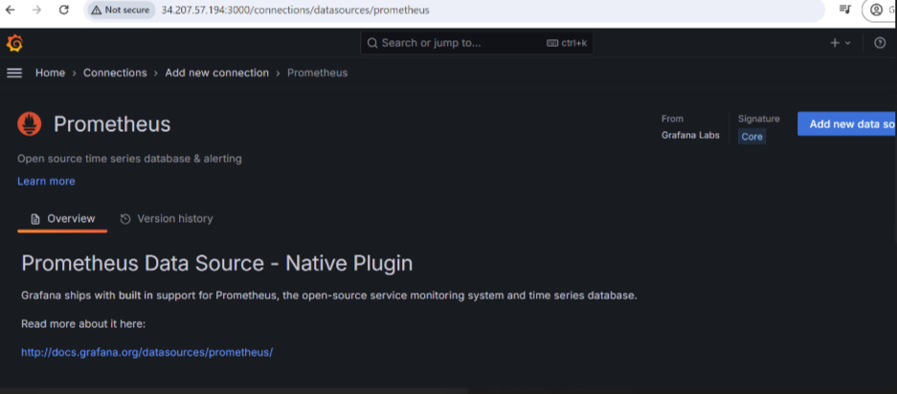

Create dashboard:

